Nature’s treasure
1. Assertion (A): Excessive use of fossil fuels leads to global warming.
Reason (R): Burning fossil fuels increases the concentration of greenhouse gases like carbon dioxide in the atmosphere.
A. Both A and R are true, and R is the correct explanation of A.
B. Both A and R are true, but R is not the correct explanation of A.
C. A is true, but R is false.
D. A is false, but R is true.

2. Assertion (A): Use of CNG in vehicles is promoted in many cities.
Reason (R): CNG burns more completely and causes less air pollution compared to petrol or diesel.
A. Both A and R are true, and R is the correct explanation of A.
B. Both A and R are true, but R is not the correct explanation of A.
C. A is true, but R is false.
D. A is false, but R is true.

3. Assertion (A): Rocks are composed of minerals which are basic components of metals like gold, copper etc.
Reason (R): Dead plants and animals get buried under layers of sediments of sedimentary rocks.
- Both A and R are true, and R is the correct explanation of A.
- Both A and R are true, but R is not the correct explanation of A.
- A is true, but R is false.
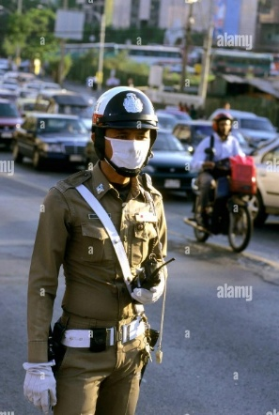
- A is false, but R is true.

4. Observe the picture carefully and answer the following questions –
A. Why does he put a cover on his nose?
B. Describe the air quality of the place shown in the image.
C. What can be done to change the quality of the air?

5. Observe the given image carefully and answer the following questions:
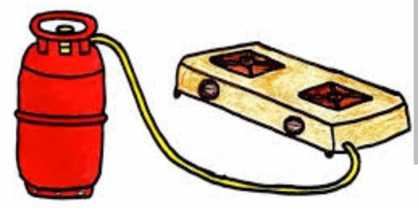
A. Write the full name of the fuel that is present inside the cylinder.
B. Write the major component of this fuel.
C. What is the molecular formula of the major component of the fuel?
D. What is the main source of the main component used in this cylinder?
E. In which state the fuel is present inside the cylinder? Justify your answer.
F. In which state does the fuel comes out of the cylinder?

